Exercise 5
IHW#3: Your firm - Common-sized income statements and price-to-earnings ratios (i.e., P/E ratios)
Aka – IHW: Your firm’ I/S and P/E

Due on ________________
Points possible ________________.

The purpose of this HW is to extend your understanding of (1) the contents and terminology of income statements, (2) the calculations and interpretations of common-sized income statements, (3) the extent to which income statements reflects the value-added activities of the firm over a period of time, and (4) the calculations, interpretation, and usefulness of price-to-earnings ratios.

Requirements: Complete the following requirements:

Readings from Financial Reporting: First Take

Read Chapter 2 from Financial Reporting: First-Take

Read Chapter 7 from Financial Reporting: First-Take

Preparation of common-sized income statements and expanded presentation for your income statement. Using your firm’s income statements for the three most recent years (you should be able to download the income statements from your firm’s website or the SEC’s EDGAR data base),

Create common-sized income statement in an Excel spreadsheet. Common-sized income statements are computed for 3M and attached on the next page of this IHW.

Create $change and %change in the Excel spreadsheet. An example is shown below for 3M. Please follow this format to prepare these measures for your firm.

Drawing inferences from the common-sized income statements and expanded presentation

Answer the following questions using your common-size income statements, your expanded presentation, and your understanding of your firm’s business strategy:

What inferences can you draw about the change in the amount of ‘revenue’ from year to year? – NVIDA is growing Revenue at an unbelievable rate. From ’22 to ’23 they grew 100.22% from ’23 to ’24 they grew again at 225.85%. The tech boom NVIDIA helped to enable in 2024 is highlighted in their revenue growth.

What inferences can you draw about the gross margin percentage over time (gross margin is defined as ‘revenue’ minus ‘cost of goods sold’)? - NVIDIA’s gross margin reduced from ’22 to ’23 but greatly improved in 2024. This is a really good shift for NVIDIA’s financial state. This should mean that a company either reduced their operating costs or increased the amount customers are willing to pay. With gross margin growth like this one would think it must be a combination of both but interestingly the Firm’s operating expenses still went up. This tells us their margin is being made mostly on price.

What inferences can you draw about the ‘selling, general, and administrative’ (SG&A) expense percentage over time? - NVIDIA has kept a stable SG&A with growth of ~10%. Growth of 10% in a normal year is not a positive metric for a Firm. Typically you would like to see this number going down but when the firm’s top line growth is as huge as it is in NVIDIA’s case we can accept the 10% growth to SG&A. This tells us that the firm is running fairly lean and controlling expenses acceptably.

What inferences can you draw about ‘operating income’ percentages over time? - Operating income is the statistic from the consolidated Income statement that really confirms the inference I gave in 3.3. From ’23 into ’24 NVIDIA grew operating income by 591%. This number shows that NVIDIA’s spending their operating cash in places that are paying back.

How do the inferences you made above seem consistent or inconsistent with your knowledge of your firm’s industry characteristics? - Revenue has grown steadily in semiconductors over the last decade but it also shows capable of assorted booms like this one for NVIDIA when coupled with technological advances. Even still this growth in Revenue is unprecedented in the semiconductor industry. Gross margin in semi conductors has also shown steady growth yoy per “Macrotrends.net”. Growth has gone from ~40% to ~60% in the industry during the last decade in 2024, NVIDIA’s 73% margin has them among the top performers in the industry and even if this type of performance isn’t sustainable, overall Gross Margin should continue to climb if the industry is any indicator.

Price to earnings ratio (P/E ratio): Answer the following questions

Calculate the P/E ratios for the three income statement dates (see below for getting the share price of your firm’s stock on the balance sheet dates).
 | 2024 | 2023 | 2022
Share price | 61.02 | 19.16 | 22.84
P/E Ratio | 51.27731092 | 112.7058824 | 58.56410256

How are these P/E ratios interpreted? The price to earnings ratio is a commonly used metric to measure a company’s performance. It tells us the ratio of stock price or assumed value compared to financial performance. A low margin would show the market is betting on reduced performance or over inflated earnings that aren’t expected to last and a high P/E ratio shows the market is betting good financial performance is expected to continue.

What reasons might exist to explain your P/E ratios for the income statement periods? Discuss.
P/E ratios are computed for 3M and shown at the bottom of the attachment to this IHW. – NVIDIA’s P/E ratio is extremely high. The market is showing a high level of belief in NVIDIA’s continued financial success. That said, this ratio is much higher than normal. NVIDIA’s stock price has soared as a result of their financial success and media hype. All financial indicators show that NVIDIA will continue to report good financials for years to come but this P/E still shows a threat of a bubble. The stock valuation greatly outweighs the firms actual financial performance even in their impressive financial year.

To get the share price of a company on a given date (e.g. 12/31/2007) use the following steps. These steps use Caterpillar as an example.
- go to http://finance.yahoo.com
- type in the company name (e.g. Caterpillar) or company code (e.g. CAT) and click "GET QUOTES"
- Click "Historical Prices" on the left-hand column under Quotes
- type in start date (e.g. Dec 31, 2007) and end date (e.g. Dec 31, 2007) and check "Daily" as we are getting the daily share price and then click "Get Prices"
- Prices will be displayed. (e.g. 72.56 under "close" would be the closing price for Caterpillar on Dec 31st, 2007.)
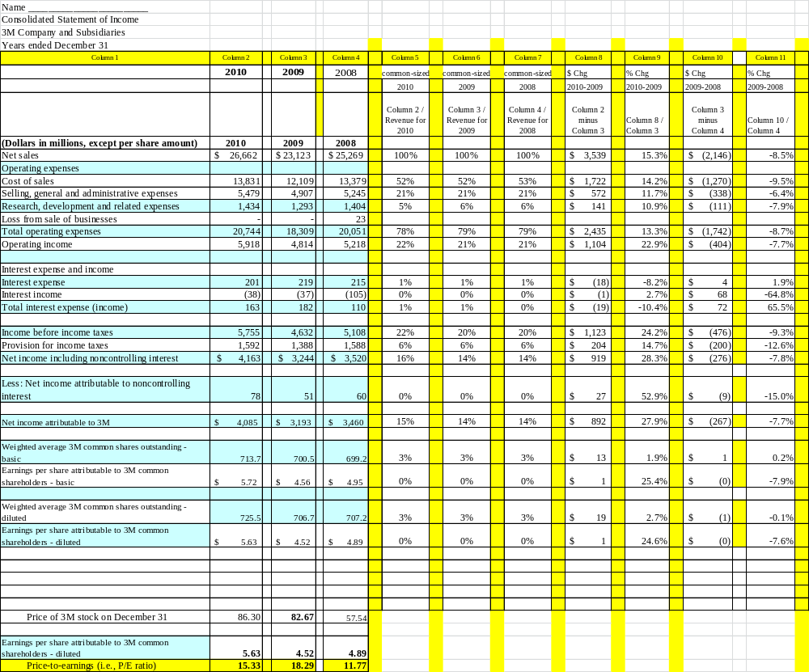

If your company has both “Total revenue / sales” or “Gross revenue / Sales” and also “Net revenue/sales” I recommend that you use Net sales as the denominator (but there is no standard approach).

